**SHORT ANSWER**

1. You are a venture capitalist. Calculate the Profit Margin for 2014 for the startup whose income statement is shown below (show work).

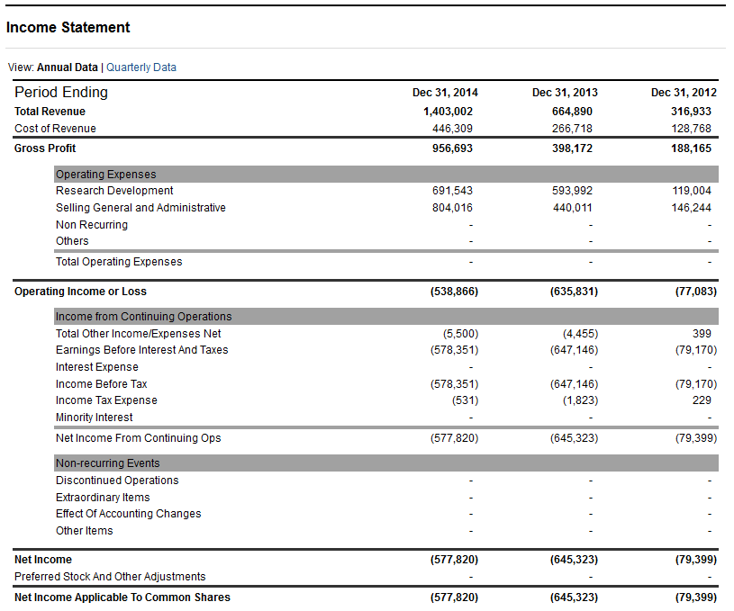

1. As the VC looking to invest in this business discuss what this number means, some reasons why this number might be low and why you still might invest (or not invest).
2. An entrepreneur decides to invest 1.2 million for a 20% stake in your business. What valuation does this put on your business? (Show work)
3. Give an example of an emerging industry and justify why you see this as an emerging industry.
4. According to the video by Paul Graham what is the main reason startups fail? (You should be able to answer this in one or two sentences)

**LONG ANSWER**

1. You want to enter the market by starting a Coffee Shop, but want to do some analysis of what the industry is like before making a decision. You decide to use Porter’s Five Forces to analyze Starbucks since you see them as an important industry leader.
   1. In the space below use the 5 Forces to conduct this analysis of Starbucks.
   2. Does your outcome make this appear like an attractive market to enter?
   3. Starbucks has done quite well, does your outcome agree with how well Starbucks has done?